**DEPLOYMENT OF WORDPRESS WITH DOCKER COMPOSE**

**What is Docker?**

* Docker is a containerization tool.
* Docker is a set of platform as a service product that uses OS-level virtualization to deliver software in packages called “Container”.
* Docker is used for developing, shipping and running application. Docker will take care of dependency to run an application.

**What is Docker-Compose?**

Docker-Compose is a tool which is used to manage multi-container based application. By using docker-compose we can deploy multi-container based application.

**Task-1:** Launch a EC2 Instance and connect to the Instance.

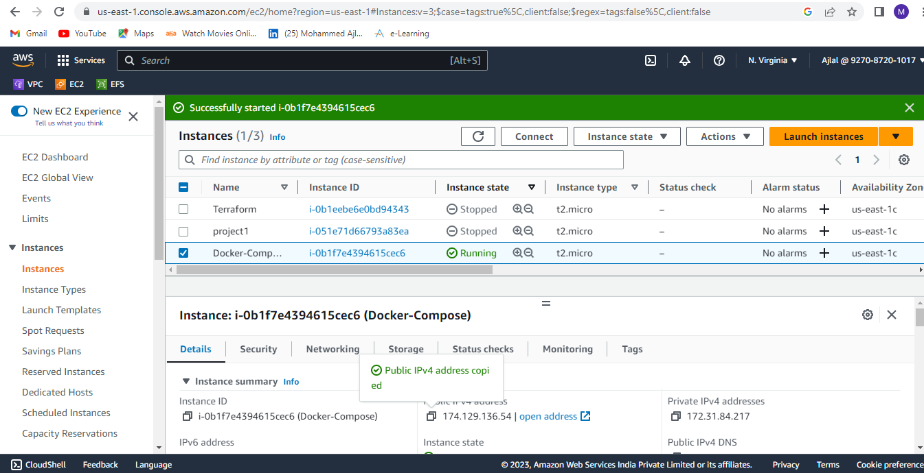

**Task-2:** Install Docker server in the instance.

Command: sudo yum install docker -y.

**Task-4:** Start the docker service.

Command: sudo service docker start

**Task-5:** Add user to docker group by executing below command.

Command: sudo usermod -aG docker ec2-user

**Task-6:** Install Docker-compose in the instance.

Command: sudo curl -L https://github.com/docker/compose/releases/download/1.22.0/docker-compose-$(uname -s)-$(uname -m) -o /usr/local/bin/docker-compose

* After installing Docker-compose add permission.

Command: sudo chmod +x /usr/local/bin/docker-compose

**Task-7:** Create a one directory with mkdir command and create one yaml file with .yaml extension (docker-compose.yaml) inside the directory.

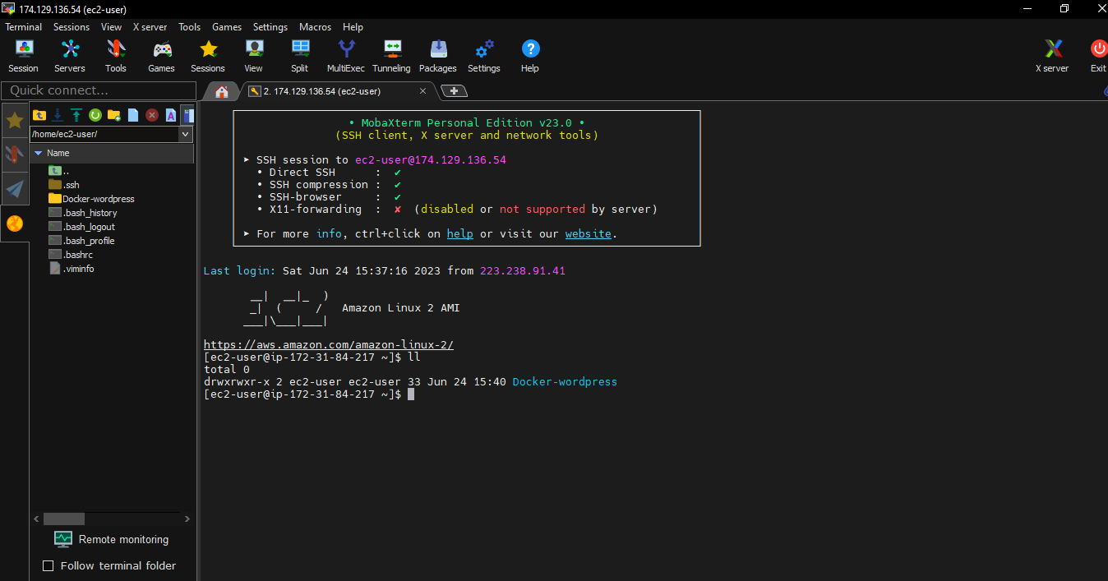

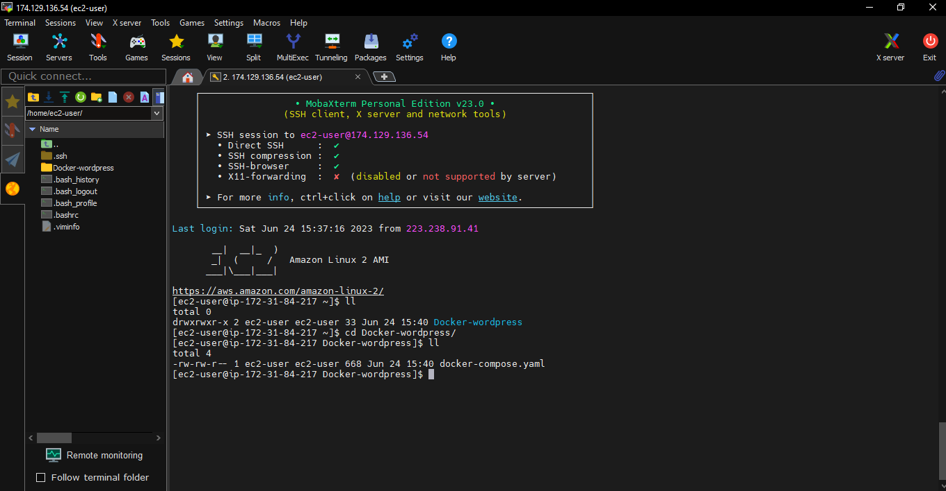

**Task-8:** Edit yaml file with vi command. write Database and WordPress configurations in the yaml file and save the file. 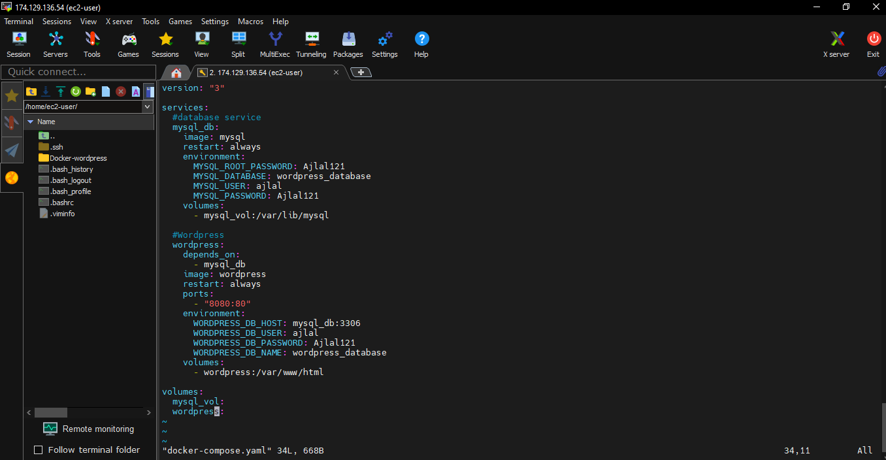

**Task-9:** After creating a yaml file start the container by executing below command.

Command: Docker-compose up -d

* Two container will start one for MYSQL and another for WordPress.

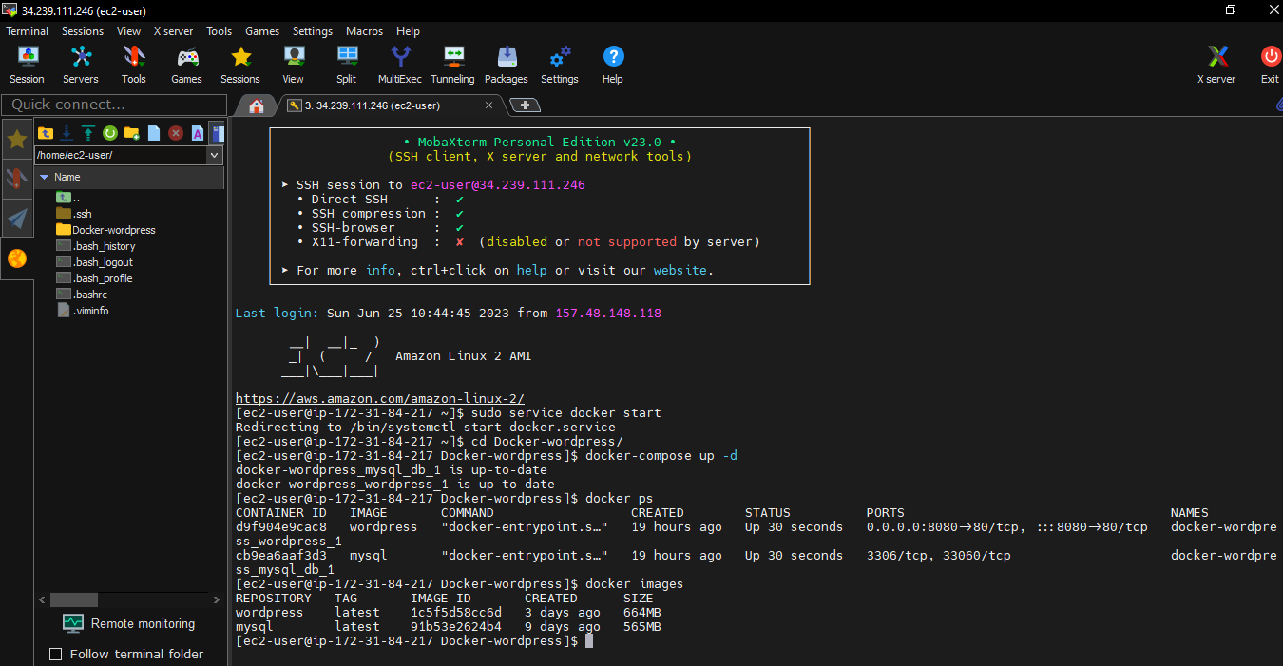

**Task-10:** After executing docker-compose up command, browse the instance public Ip with 8080 port to check WordPress output.

